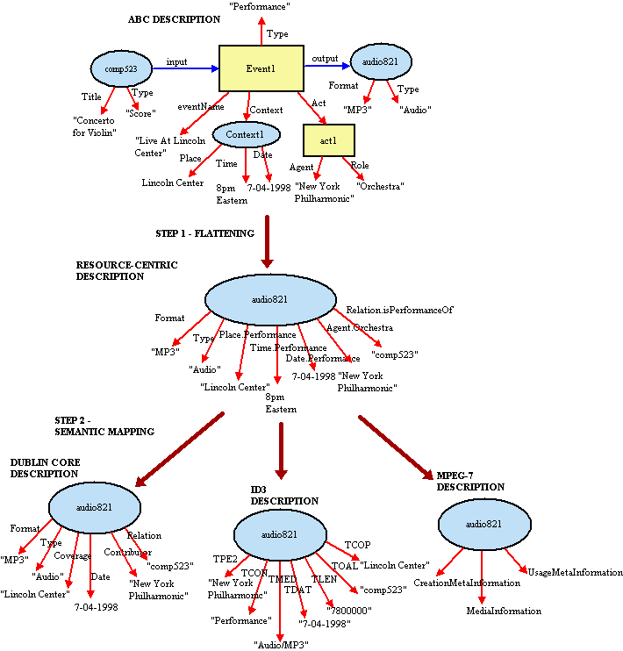
Figure 2: Transformation from the ABC Event-aware Model to 3 Different Resource-centric Models

Jane Hunter, MetaNet - A Metadata Term Thesaurus to Enable Semantic Interoperability Between Metadata Domains
http://archive.dstc.edu.au/RDU/staff/jane-hunter/harmony/jodi_article.html

